RM 9–NU: My Lifestyle Choices and Energy Balance*
Name |  | Class |  | Date
Energy
Expenditure

Energy
Expenditure
- activity
- metabolism

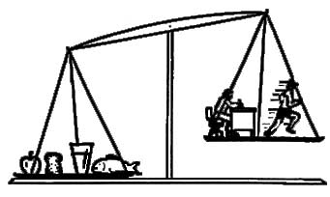
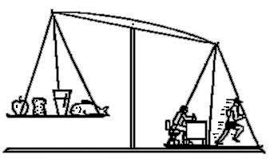

Energy
Intake
Energy
Intake

Factors that contribute to an energy imbalance that could lead to weight gain:

Counter measures that could help me regain energy balance:

Describe what you have learned about yourself related to your food choices and physical activity habits. Indicate where you can make positive changes and what you plan to do.

__________
* Source: Dairy Farmers of Manitoba, 2008, 2003. Adapted with permission.

